**HIVE Task-2**

1. Import RStudio Log Files from s from one week in February 2019 iinto HDFS

Step-1 Download one week Logs from http://cran-logs.rstudio.com/

Step-2 Create a new folder to store downloaded logs files

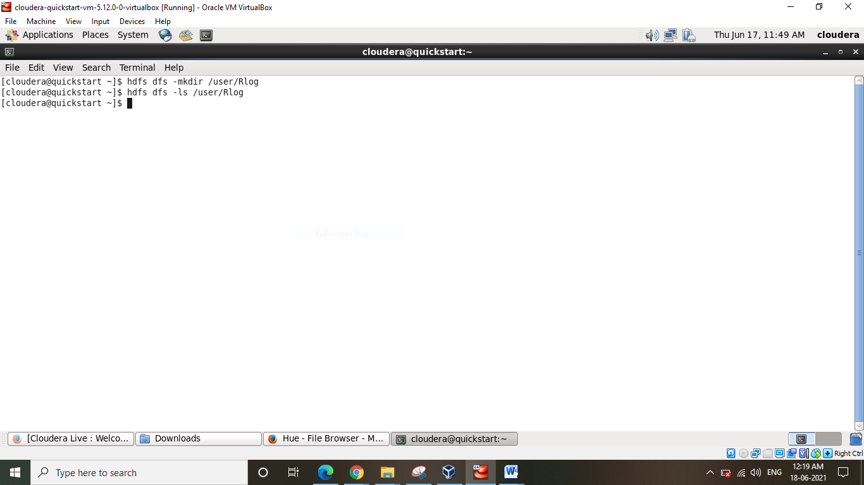

Step-3 Unzip all *.zip files

Step-4 Put on ?HDFS and verify

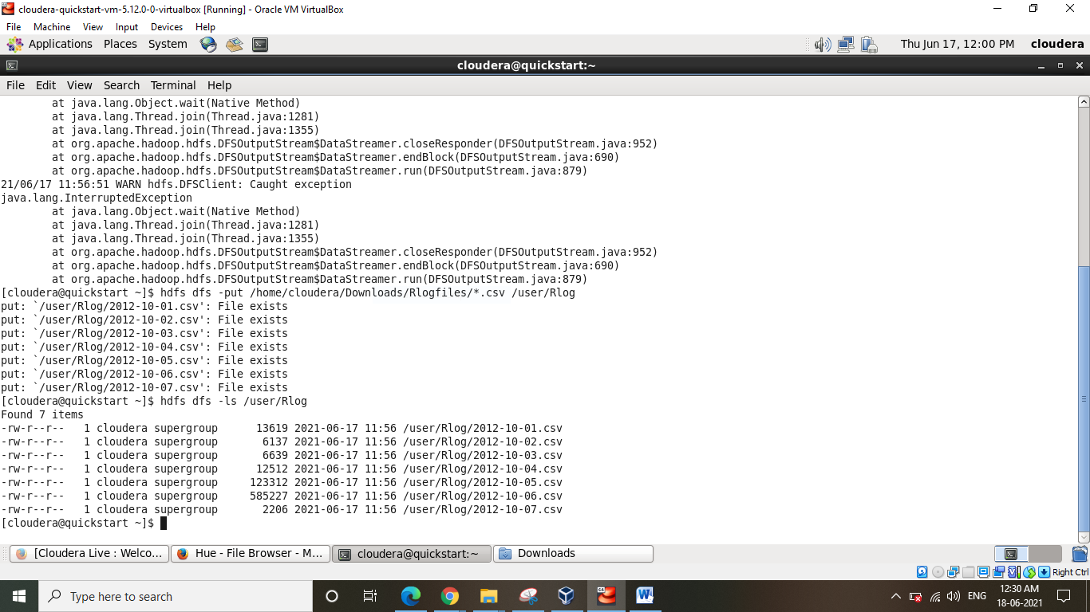

1. Load log-file of one day (e.g., 1st of February 2019)

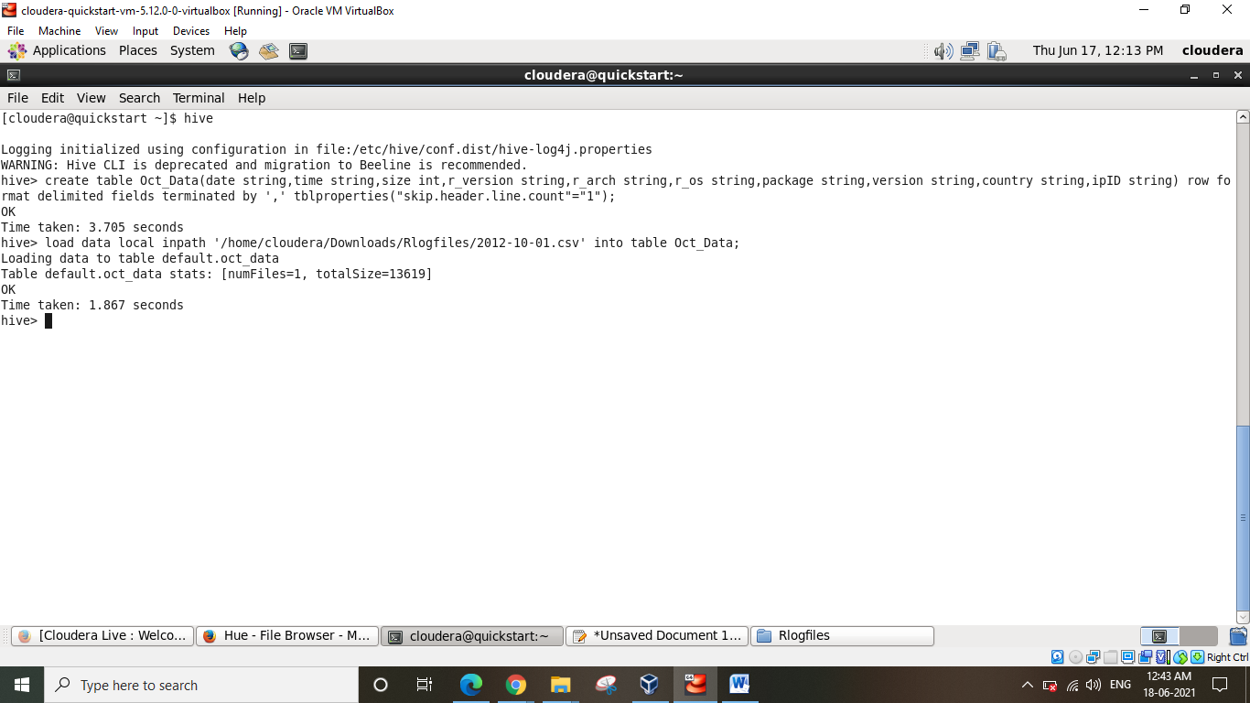

1. Dump the first 10 entries on screen (attach a screen shot into your report) to check if it works or not

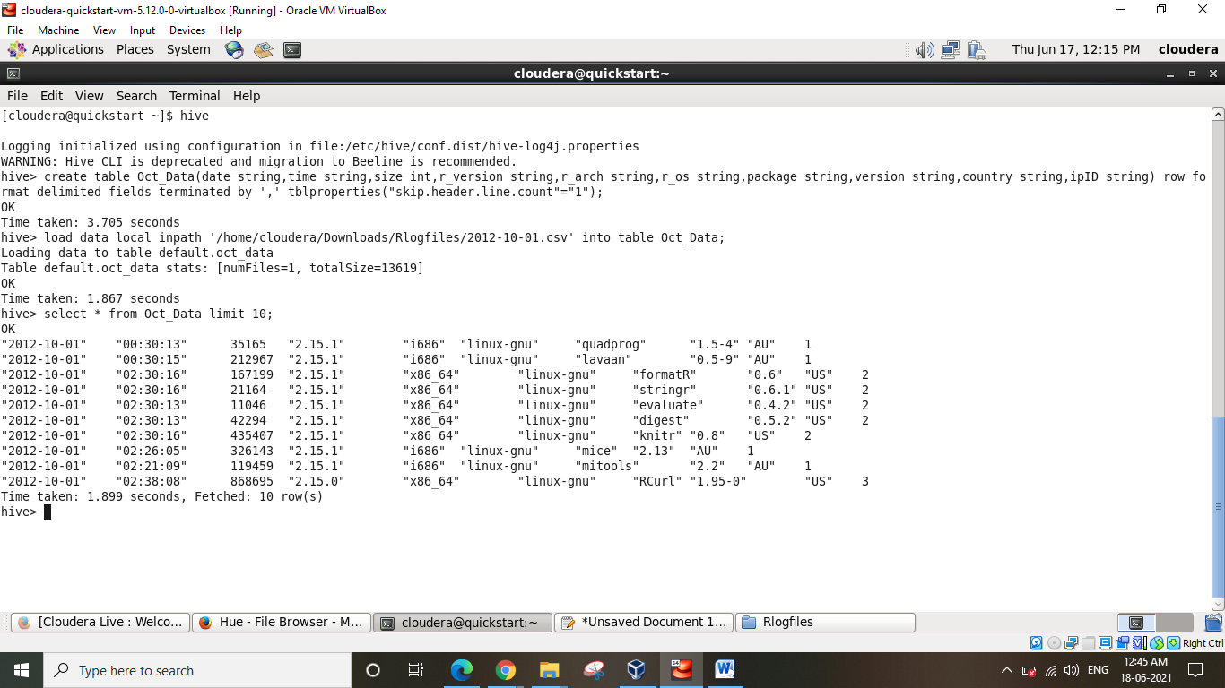

1. Count the number of occurrences of different packages.

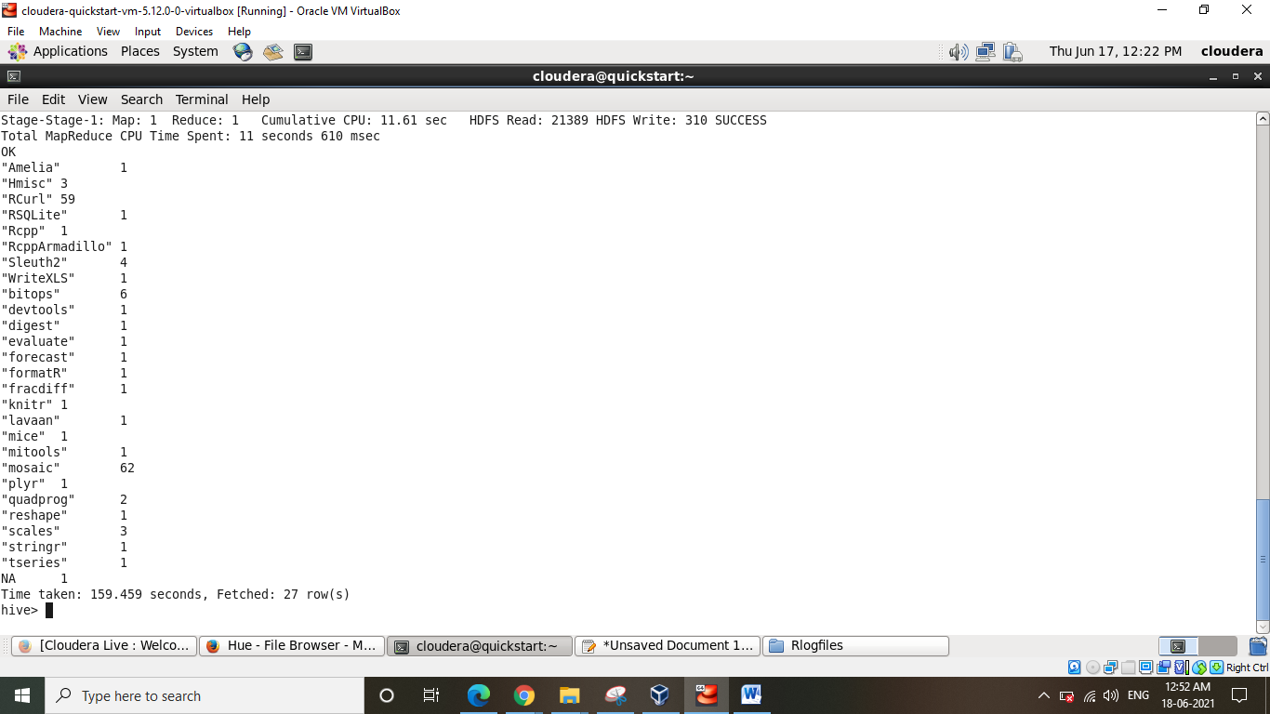

1. Count the number of occurrences of different packages by operating system.

